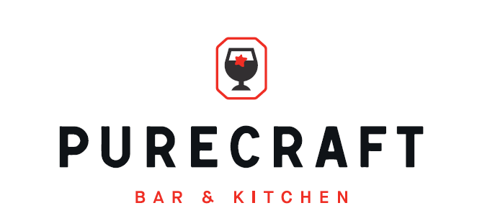

Sunday lunch menu
BBQ’d ½ Chicken, garlic & parsley butter (GF)
With pork dripping potatoes, charred tender stem broccoli, honey glazed carrots and a pint of Purity beer
£24

Rump cap of beef, garlic & parsley butter (GF)
With pork dripping potatoes, charred tender stem broccoli, honey glazed carrots and a pint of Purity beer
£28

Cauliflower steak, chimichurri (GF, VE)
With glazed carrots, tender stem broccoli, crispy potatoes and a pint of Purity beer
£16

